Day 2!

Basic Sketches!

Make sure you’re in Design

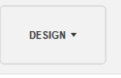

Click the button right next to it

 and you’ll get something that looks like this

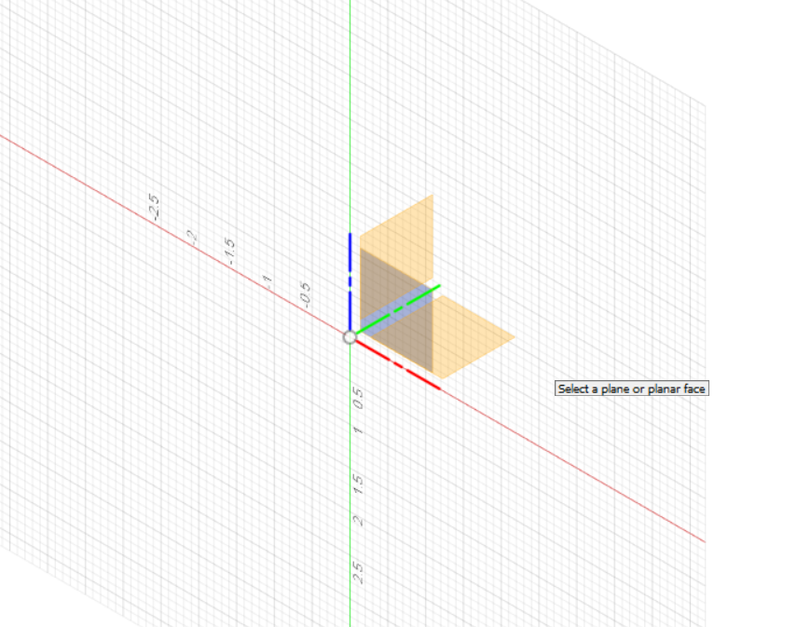

We’re gonna click the bottom plane

Now your screen should look like this

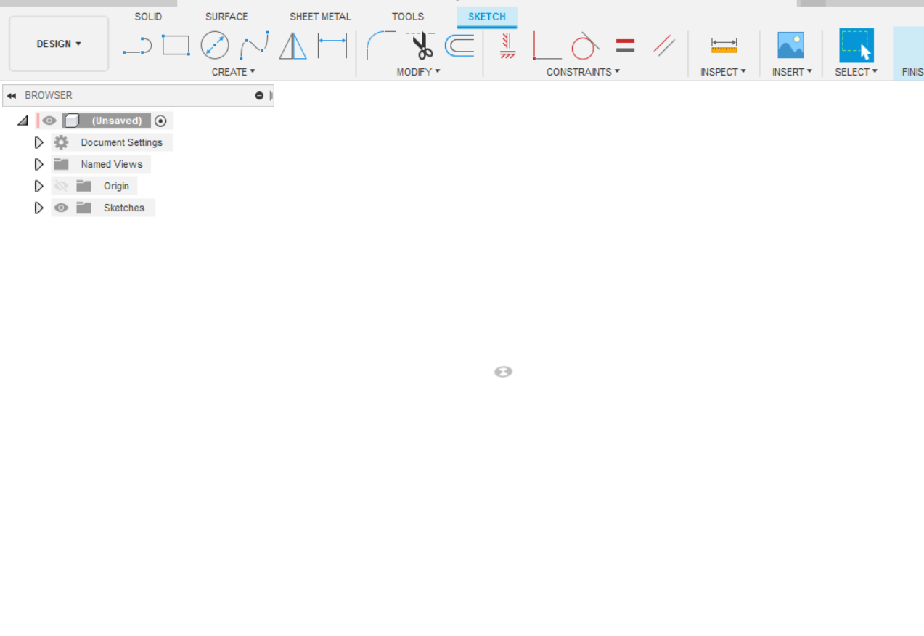

It can also look like this: I just have my grid off. These are the same thing! 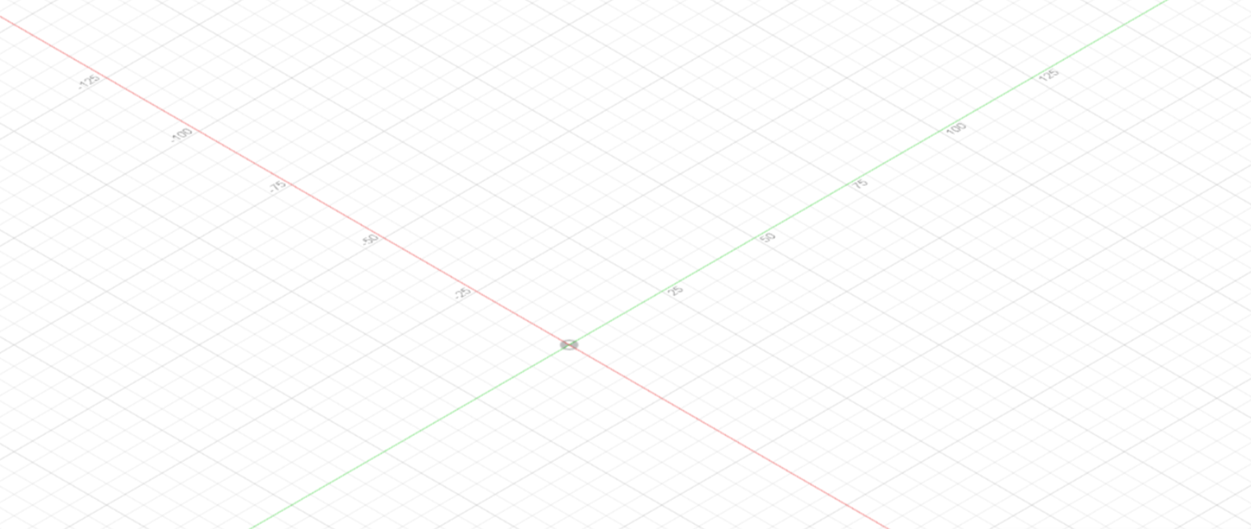

nice and empty and ready to be filled!

Cool; we’re gonna learn relations

Click the line tool: 

Make any shape with 4 lines

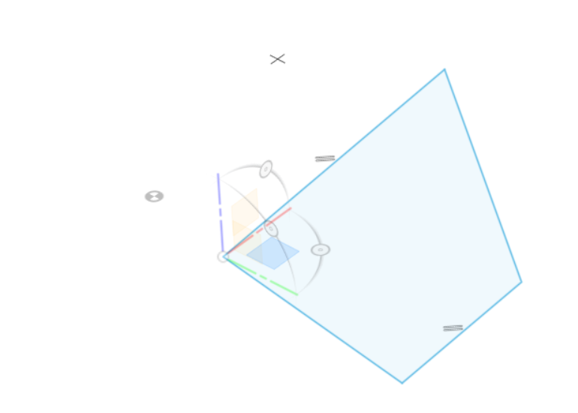

Blue means it’s unconstrained; malleable

All of our finished designs should be black lined: constrained

We’re gonna constrain this bad boy!

Click the equal: 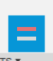

Now make all the lines equal to each other

* Note: when something is overconstrained this will pop up:

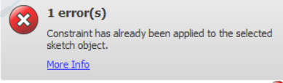

* Don't worry, this just means you’ve already done that!

Okay! Now let’s make it a square!

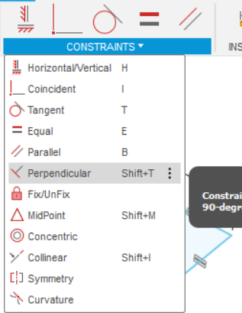

Click on perpendicular then click the adjacent lines until it is a square.

Note: if you ever have to use fix/unfix that’s not a good sign. Everything should be constrained in relation to other things. If you ever think you absolutely need to use it on the plane design please let a design team lead know and we’ll check it out

Alright now pick any number

Got it? Alright good

Mine’s 42.0 and i’ll be setting one of the sides of the square to that number and that’ll make all the sides 42.0 inches long!

Click dimension (d on keyboard) or at the bottom of the list that pops down from “create”

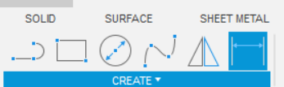

And click one of the lines and click again, fill in the number you chose (the new length) in the space that appears.

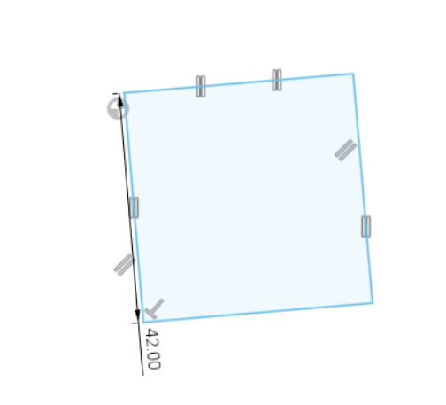

This is what I get now, all the other lines will already match the new size because you already made them equal in length.

Okay so now you’re gonna constrain it geographically as well

We’re gonna place one of the corners on the origin

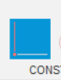

Click the coincident

Then click the origin and one corner

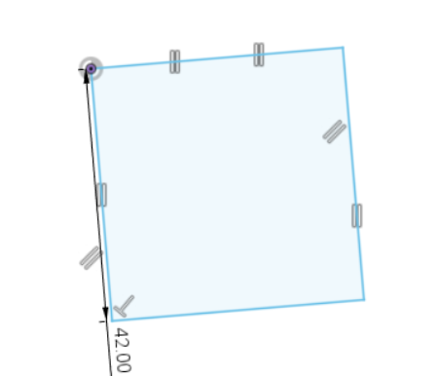

Yay!

Last step: we’re going to constrain the angle off the x y plane

click on horizontal/ vertical

Now click any of the lines

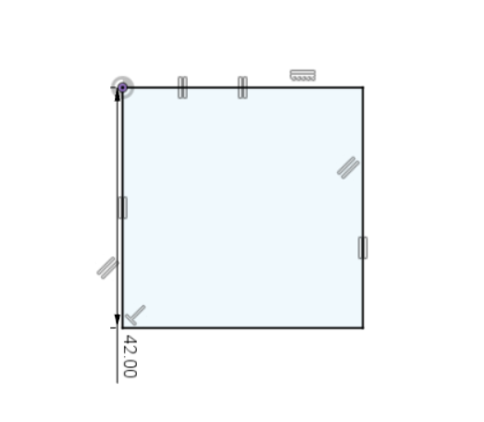

Yay!! Now it’s ALL constrained!!

Challenge time!

Create and constrain any polygon

Here’s mine:

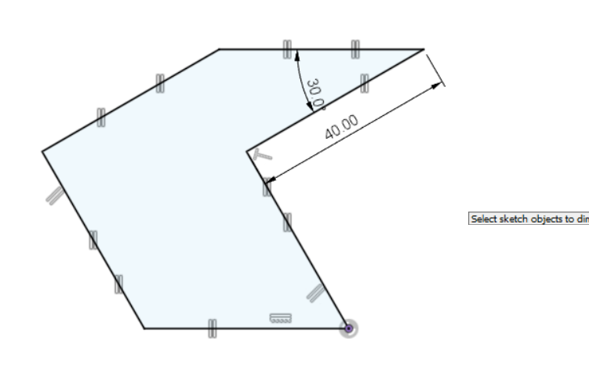

I challenge you to make a shape using every single one of Fusion’s constraint functions

* It SUPER helps with learning the program
* Okay ! Day 3! Go !